**Игра «Жадина»**

*(Представьте, что это ваши фрукты. Ответьте на вопросы: Чей это лимон? (Мой лимон.) Чья слива? (Моя слива.) Чьё яблоко? (Моё яблоко.) И т.д.*

|  |  |
| --- | --- |
| https://clipartspub.com/images/clipart-banana-transparent.png | https://1.bp.blogspot.com/-1ySuxMlP23c/X4HTKk8n7eI/AAAAAAAA9z8/McF01TA846k0Aj-KQucsB3-5s7swKQneACLcBGAsYHQ/s2048/%25D1%258F%25D0%25B1%25D0%25BB%25D0%25BE%25D0%25BA%25D0%25BE_DoV%2B%252811%2529.png |
| *https://1.bp.blogspot.com/-yTmJts7XHI0/X4HRGvXdmPI/AAAAAAAA9yc/JKsQFmeXq6I1cyDnapw8t7OVgDRSRTYzACLcBGAsYHQ/s2048/%25D1%2581%25D0%25BB%25D0%25B8%25D0%25B2%25D0%25B0_DoV%2B%25283%2529.png* | *https://www.6sotok-pnz.ru/upload/iblock/e30/e30d0139c8fee9ba08e503a407b0ecd2.jpg* |
| *https://cdn.pixabay.com/photo/2018/04/18/11/33/lemon-3330200_1280.png* | *https://cs.pikabu.ru/post_img/big/2013/12/09/8/1386593825_1447495896.jpg* |
| *https://yt3.ggpht.com/a/AATXAJxAzqGJPcbDcM2P9fITfugql6x5YbuVWRB_gWS6PA=s900-c-k-c0x00ffffff-no-rj* | *https://pbs.twimg.com/media/EFSheRDXUAYAqFN.jpg:large* |
| *https://clipart-best.com/img/apricot/apricot-clip-art-7.png* | *https://gwpriceltd.co.uk/wp-content/uploads/2020/04/GWPrice-Kiwi-fruit-min-1024x1024.jpg* |

**Игра «Один – много»**

|  |  |
| --- | --- |
| https://clipartspub.com/images/clipart-banana-transparent.png | *https://clipartspub.com/images/clipart-banana-transparent.pnghttps://clipartspub.com/images/clipart-banana-transparent.pnghttps://clipartspub.com/images/clipart-banana-transparent.png*  *https://clipartspub.com/images/clipart-banana-transparent.pnghttps://clipartspub.com/images/clipart-banana-transparent.png* |
| *https://1.bp.blogspot.com/-yTmJts7XHI0/X4HRGvXdmPI/AAAAAAAA9yc/JKsQFmeXq6I1cyDnapw8t7OVgDRSRTYzACLcBGAsYHQ/s2048/%25D1%2581%25D0%25BB%25D0%25B8%25D0%25B2%25D0%25B0_DoV%2B%25283%2529.png* | *https://1.bp.blogspot.com/-yTmJts7XHI0/X4HRGvXdmPI/AAAAAAAA9yc/JKsQFmeXq6I1cyDnapw8t7OVgDRSRTYzACLcBGAsYHQ/s2048/%25D1%2581%25D0%25BB%25D0%25B8%25D0%25B2%25D0%25B0_DoV%2B%25283%2529.pnghttps://1.bp.blogspot.com/-yTmJts7XHI0/X4HRGvXdmPI/AAAAAAAA9yc/JKsQFmeXq6I1cyDnapw8t7OVgDRSRTYzACLcBGAsYHQ/s2048/%25D1%2581%25D0%25BB%25D0%25B8%25D0%25B2%25D0%25B0_DoV%2B%25283%2529.pnghttps://1.bp.blogspot.com/-yTmJts7XHI0/X4HRGvXdmPI/AAAAAAAA9yc/JKsQFmeXq6I1cyDnapw8t7OVgDRSRTYzACLcBGAsYHQ/s2048/%25D1%2581%25D0%25BB%25D0%25B8%25D0%25B2%25D0%25B0_DoV%2B%25283%2529.png*  *https://1.bp.blogspot.com/-yTmJts7XHI0/X4HRGvXdmPI/AAAAAAAA9yc/JKsQFmeXq6I1cyDnapw8t7OVgDRSRTYzACLcBGAsYHQ/s2048/%25D1%2581%25D0%25BB%25D0%25B8%25D0%25B2%25D0%25B0_DoV%2B%25283%2529.pnghttps://1.bp.blogspot.com/-yTmJts7XHI0/X4HRGvXdmPI/AAAAAAAA9yc/JKsQFmeXq6I1cyDnapw8t7OVgDRSRTYzACLcBGAsYHQ/s2048/%25D1%2581%25D0%25BB%25D0%25B8%25D0%25B2%25D0%25B0_DoV%2B%25283%2529.png* |
| *https://cdn.pixabay.com/photo/2018/04/18/11/33/lemon-3330200_1280.png* | *https://cdn.pixabay.com/photo/2018/04/18/11/33/lemon-3330200_1280.pnghttps://cdn.pixabay.com/photo/2018/04/18/11/33/lemon-3330200_1280.pnghttps://cdn.pixabay.com/photo/2018/04/18/11/33/lemon-3330200_1280.png*  *https://cdn.pixabay.com/photo/2018/04/18/11/33/lemon-3330200_1280.pnghttps://cdn.pixabay.com/photo/2018/04/18/11/33/lemon-3330200_1280.png* |
| *https://yt3.ggpht.com/a/AATXAJxAzqGJPcbDcM2P9fITfugql6x5YbuVWRB_gWS6PA=s900-c-k-c0x00ffffff-no-rj* | *https://yt3.ggpht.com/a/AATXAJxAzqGJPcbDcM2P9fITfugql6x5YbuVWRB_gWS6PA=s900-c-k-c0x00ffffff-no-rjhttps://yt3.ggpht.com/a/AATXAJxAzqGJPcbDcM2P9fITfugql6x5YbuVWRB_gWS6PA=s900-c-k-c0x00ffffff-no-rjhttps://yt3.ggpht.com/a/AATXAJxAzqGJPcbDcM2P9fITfugql6x5YbuVWRB_gWS6PA=s900-c-k-c0x00ffffff-no-rj*  *https://yt3.ggpht.com/a/AATXAJxAzqGJPcbDcM2P9fITfugql6x5YbuVWRB_gWS6PA=s900-c-k-c0x00ffffff-no-rjhttps://yt3.ggpht.com/a/AATXAJxAzqGJPcbDcM2P9fITfugql6x5YbuVWRB_gWS6PA=s900-c-k-c0x00ffffff-no-rj* |
| *https://clipart-best.com/img/apricot/apricot-clip-art-7.png* | *https://clipart-best.com/img/apricot/apricot-clip-art-7.pnghttps://clipart-best.com/img/apricot/apricot-clip-art-7.pnghttps://clipart-best.com/img/apricot/apricot-clip-art-7.png*  *https://clipart-best.com/img/apricot/apricot-clip-art-7.pnghttps://clipart-best.com/img/apricot/apricot-clip-art-7.png* |

**Игра «Один – много»**

|  |  |
| --- | --- |
| *https://1.bp.blogspot.com/-1ySuxMlP23c/X4HTKk8n7eI/AAAAAAAA9z8/McF01TA846k0Aj-KQucsB3-5s7swKQneACLcBGAsYHQ/s2048/%25D1%258F%25D0%25B1%25D0%25BB%25D0%25BE%25D0%25BA%25D0%25BE_DoV%2B%252811%2529.png* | *https://1.bp.blogspot.com/-1ySuxMlP23c/X4HTKk8n7eI/AAAAAAAA9z8/McF01TA846k0Aj-KQucsB3-5s7swKQneACLcBGAsYHQ/s2048/%25D1%258F%25D0%25B1%25D0%25BB%25D0%25BE%25D0%25BA%25D0%25BE_DoV%2B%252811%2529.pnghttps://1.bp.blogspot.com/-1ySuxMlP23c/X4HTKk8n7eI/AAAAAAAA9z8/McF01TA846k0Aj-KQucsB3-5s7swKQneACLcBGAsYHQ/s2048/%25D1%258F%25D0%25B1%25D0%25BB%25D0%25BE%25D0%25BA%25D0%25BE_DoV%2B%252811%2529.pnghttps://1.bp.blogspot.com/-1ySuxMlP23c/X4HTKk8n7eI/AAAAAAAA9z8/McF01TA846k0Aj-KQucsB3-5s7swKQneACLcBGAsYHQ/s2048/%25D1%258F%25D0%25B1%25D0%25BB%25D0%25BE%25D0%25BA%25D0%25BE_DoV%2B%252811%2529.png*  *https://1.bp.blogspot.com/-1ySuxMlP23c/X4HTKk8n7eI/AAAAAAAA9z8/McF01TA846k0Aj-KQucsB3-5s7swKQneACLcBGAsYHQ/s2048/%25D1%258F%25D0%25B1%25D0%25BB%25D0%25BE%25D0%25BA%25D0%25BE_DoV%2B%252811%2529.pnghttps://1.bp.blogspot.com/-1ySuxMlP23c/X4HTKk8n7eI/AAAAAAAA9z8/McF01TA846k0Aj-KQucsB3-5s7swKQneACLcBGAsYHQ/s2048/%25D1%258F%25D0%25B1%25D0%25BB%25D0%25BE%25D0%25BA%25D0%25BE_DoV%2B%252811%2529.png* |
| *https://www.6sotok-pnz.ru/upload/iblock/e30/e30d0139c8fee9ba08e503a407b0ecd2.jpg* | *https://www.6sotok-pnz.ru/upload/iblock/e30/e30d0139c8fee9ba08e503a407b0ecd2.jpghttps://www.6sotok-pnz.ru/upload/iblock/e30/e30d0139c8fee9ba08e503a407b0ecd2.jpghttps://www.6sotok-pnz.ru/upload/iblock/e30/e30d0139c8fee9ba08e503a407b0ecd2.jpg*  *https://www.6sotok-pnz.ru/upload/iblock/e30/e30d0139c8fee9ba08e503a407b0ecd2.jpghttps://www.6sotok-pnz.ru/upload/iblock/e30/e30d0139c8fee9ba08e503a407b0ecd2.jpg* |
| *https://cs.pikabu.ru/post_img/big/2013/12/09/8/1386593825_1447495896.jpg* | *https://cs.pikabu.ru/post_img/big/2013/12/09/8/1386593825_1447495896.jpghttps://cs.pikabu.ru/post_img/big/2013/12/09/8/1386593825_1447495896.jpghttps://cs.pikabu.ru/post_img/big/2013/12/09/8/1386593825_1447495896.jpg*  *https://cs.pikabu.ru/post_img/big/2013/12/09/8/1386593825_1447495896.jpghttps://cs.pikabu.ru/post_img/big/2013/12/09/8/1386593825_1447495896.jpg* |
| *https://pbs.twimg.com/media/EFSheRDXUAYAqFN.jpg:large* | *https://pbs.twimg.com/media/EFSheRDXUAYAqFN.jpg:largehttps://pbs.twimg.com/media/EFSheRDXUAYAqFN.jpg:largehttps://pbs.twimg.com/media/EFSheRDXUAYAqFN.jpg:large*  *https://pbs.twimg.com/media/EFSheRDXUAYAqFN.jpg:largehttps://pbs.twimg.com/media/EFSheRDXUAYAqFN.jpg:large* |
| *https://gwpriceltd.co.uk/wp-content/uploads/2020/04/GWPrice-Kiwi-fruit-min-1024x1024.jpg* | *https://my-izumrud.ru/wp-content/uploads/2019/04/kivi_2.jpghttps://my-izumrud.ru/wp-content/uploads/2019/04/kivi_2.jpghttps://my-izumrud.ru/wp-content/uploads/2019/04/kivi_2.jpg*  *https://my-izumrud.ru/wp-content/uploads/2019/04/kivi_2.jpghttps://my-izumrud.ru/wp-content/uploads/2019/04/kivi_2.jpg* |

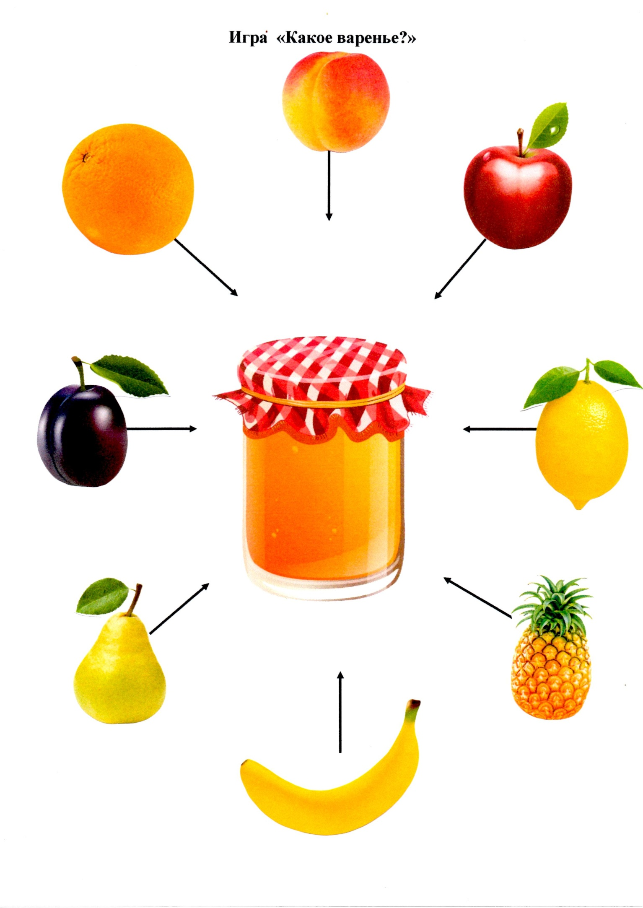

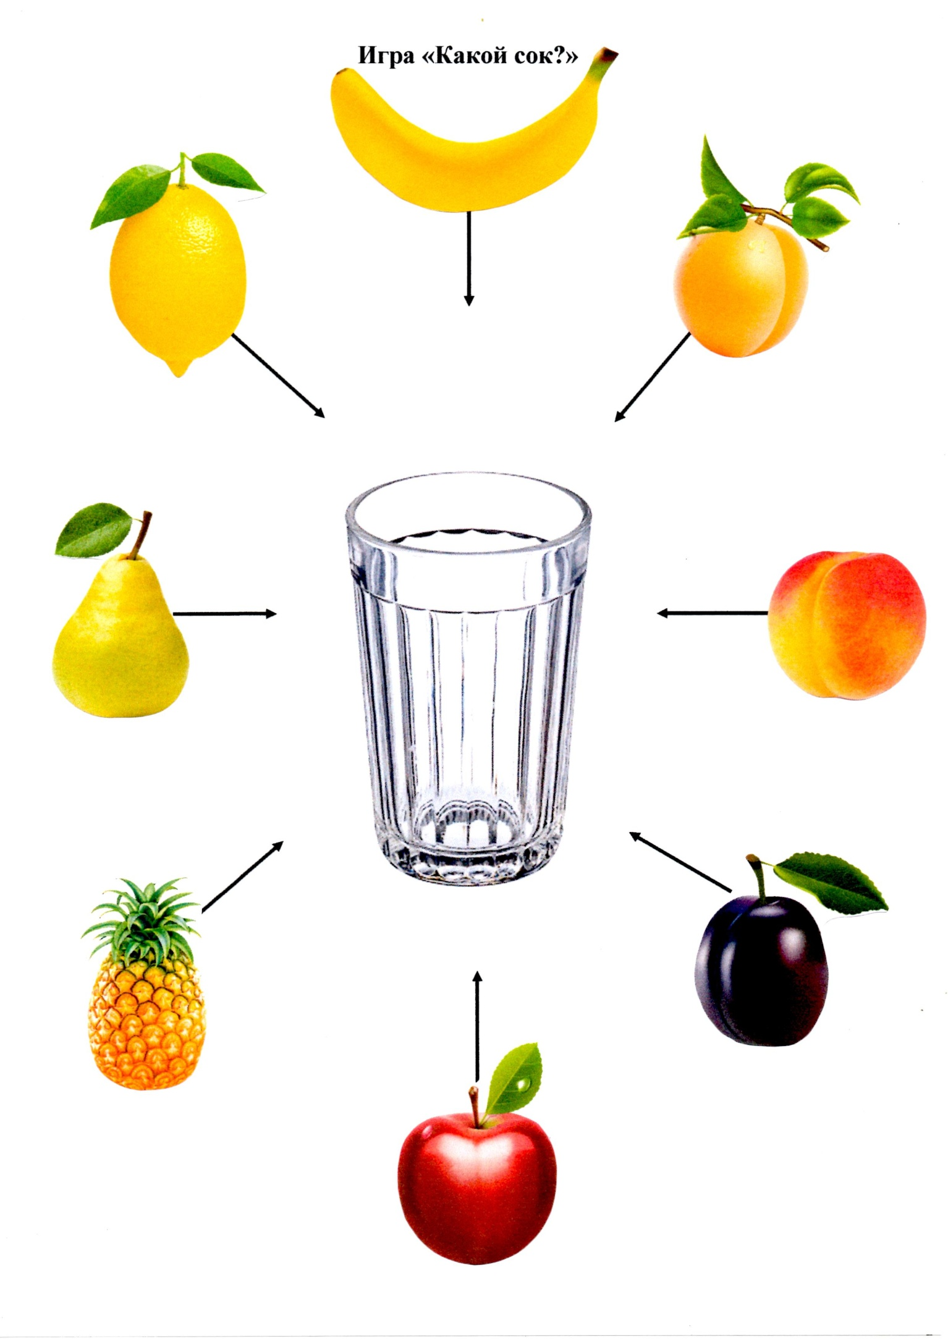

**Игра «Назови ласково»**

*(Образование уменьшительно-ласкательных форм, яблоко-яблочко)*

|  |  |
| --- | --- |
| https://clipartspub.com/images/clipart-banana-transparent.png | *https://clipartspub.com/images/clipart-banana-transparent.png* |
| *https://1.bp.blogspot.com/-yTmJts7XHI0/X4HRGvXdmPI/AAAAAAAA9yc/JKsQFmeXq6I1cyDnapw8t7OVgDRSRTYzACLcBGAsYHQ/s2048/%25D1%2581%25D0%25BB%25D0%25B8%25D0%25B2%25D0%25B0_DoV%2B%25283%2529.png* | *https://1.bp.blogspot.com/-yTmJts7XHI0/X4HRGvXdmPI/AAAAAAAA9yc/JKsQFmeXq6I1cyDnapw8t7OVgDRSRTYzACLcBGAsYHQ/s2048/%25D1%2581%25D0%25BB%25D0%25B8%25D0%25B2%25D0%25B0_DoV%2B%25283%2529.png* |
| *https://cdn.pixabay.com/photo/2018/04/18/11/33/lemon-3330200_1280.png* | *https://cdn.pixabay.com/photo/2018/04/18/11/33/lemon-3330200_1280.png* |
| *https://yt3.ggpht.com/a/AATXAJxAzqGJPcbDcM2P9fITfugql6x5YbuVWRB_gWS6PA=s900-c-k-c0x00ffffff-no-rj* | *https://yt3.ggpht.com/a/AATXAJxAzqGJPcbDcM2P9fITfugql6x5YbuVWRB_gWS6PA=s900-c-k-c0x00ffffff-no-rj* |
| *https://1.bp.blogspot.com/-1ySuxMlP23c/X4HTKk8n7eI/AAAAAAAA9z8/McF01TA846k0Aj-KQucsB3-5s7swKQneACLcBGAsYHQ/s2048/%25D1%258F%25D0%25B1%25D0%25BB%25D0%25BE%25D0%25BA%25D0%25BE_DoV%2B%252811%2529.png* | *https://1.bp.blogspot.com/-1ySuxMlP23c/X4HTKk8n7eI/AAAAAAAA9z8/McF01TA846k0Aj-KQucsB3-5s7swKQneACLcBGAsYHQ/s2048/%25D1%258F%25D0%25B1%25D0%25BB%25D0%25BE%25D0%25BA%25D0%25BE_DoV%2B%252811%2529.png* |

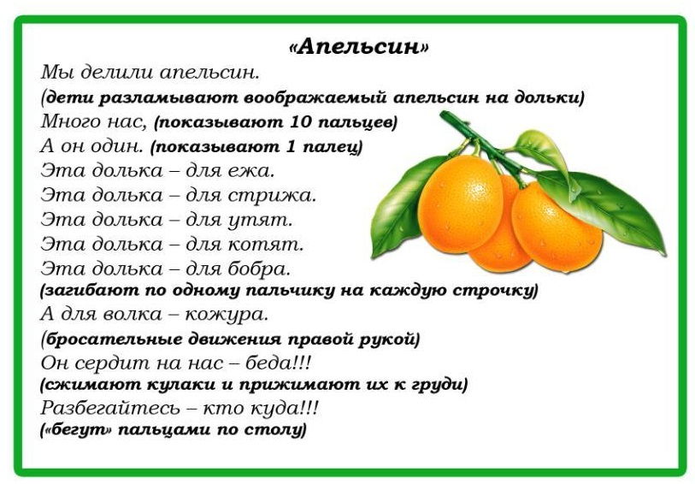

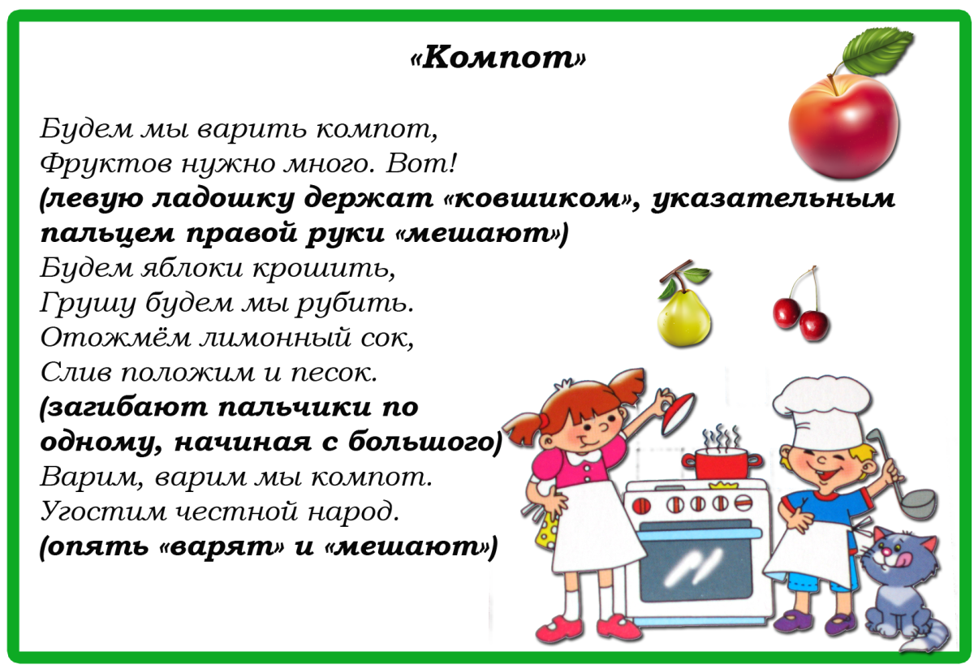

**ФРУКТЫ**

*(Рассмотри, назови по одному, назови, одним словом)*

